Nama : Lilis Sonia

NIM :18090051

Kelas : 5D

**PRAKTIKUM 4**

1. Source Code

Web.php => application/controller/Web

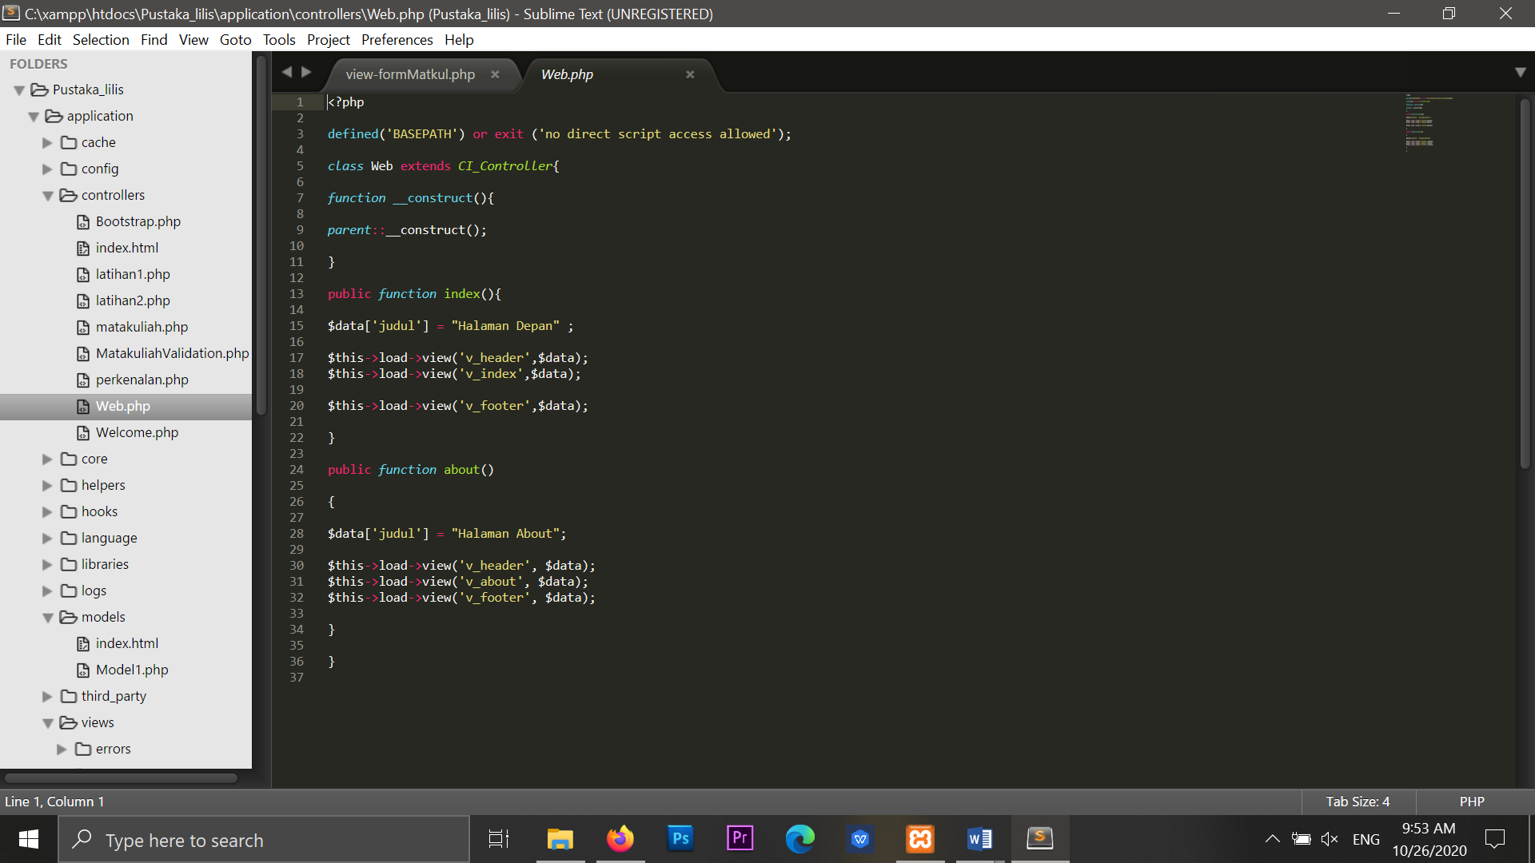

v_header.php => application/views/v_header

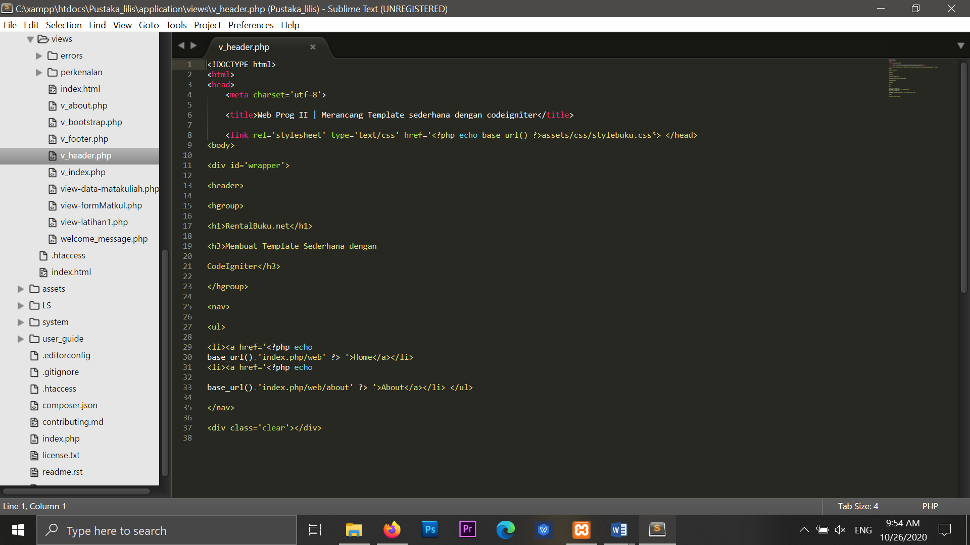

v_index.php => application/views/v_index

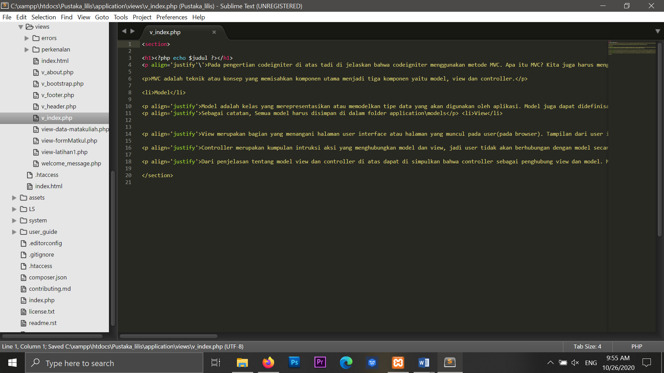

v_footer.php = > application/views/v_footer

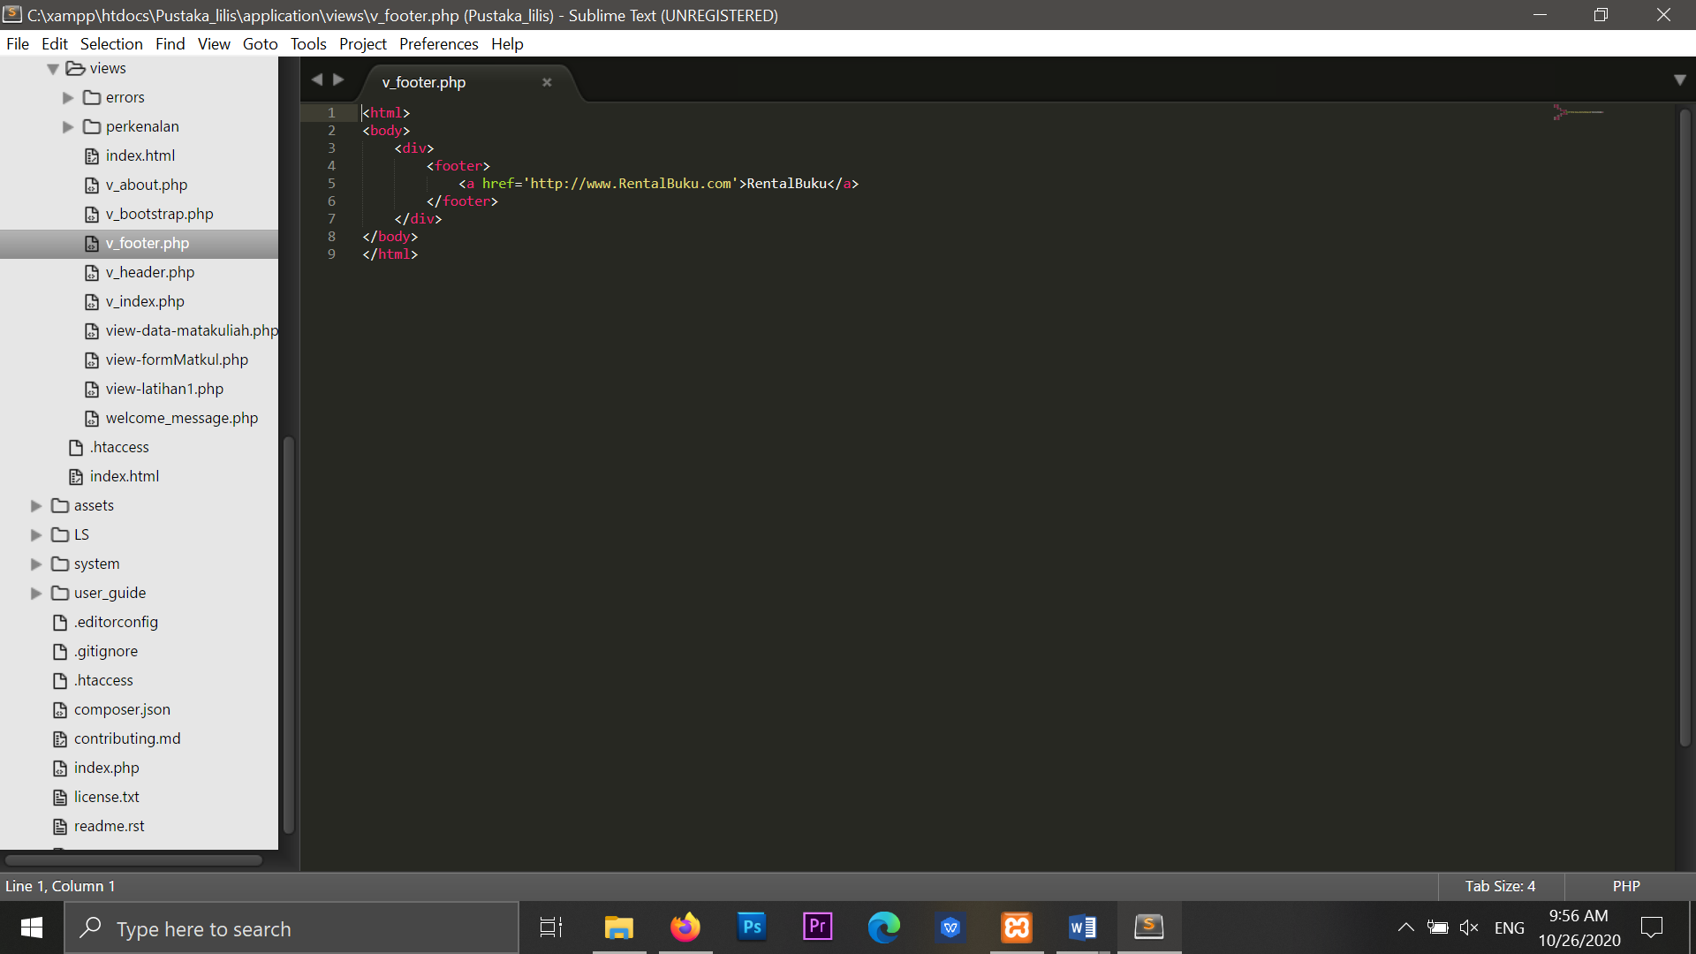

v_about.php => application/views/v_about

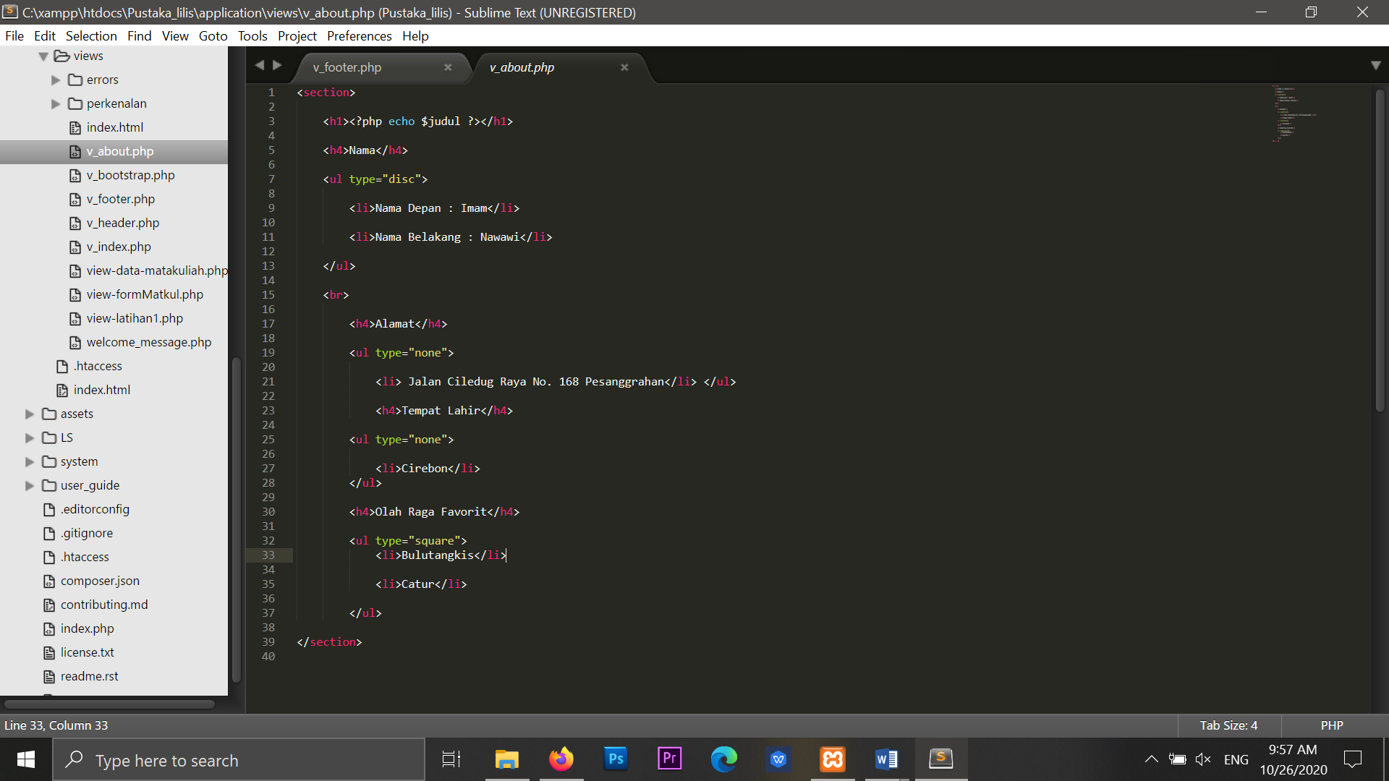

stylebuku.css => assets/css

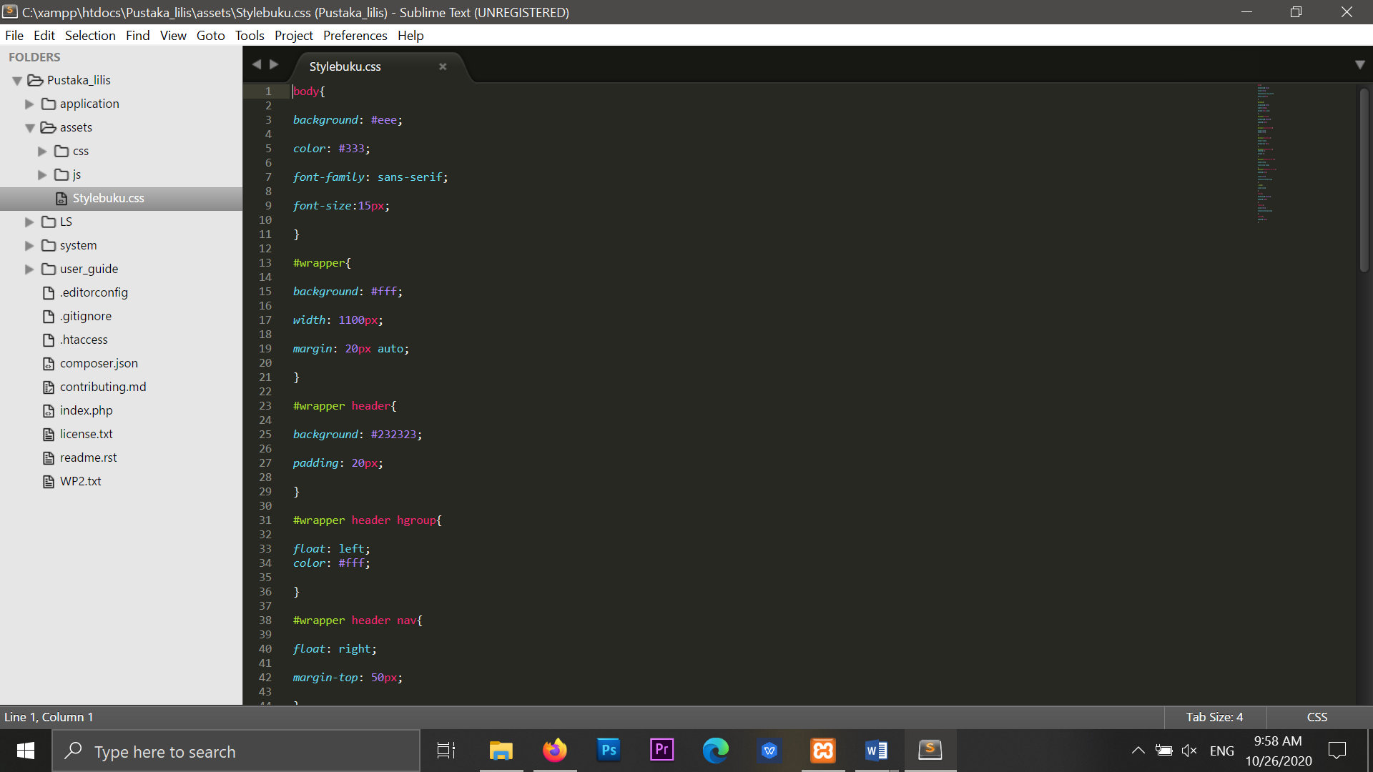 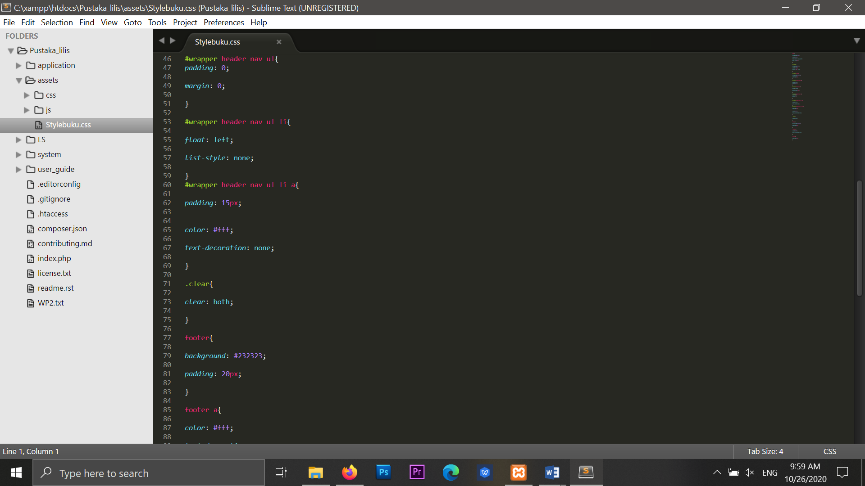 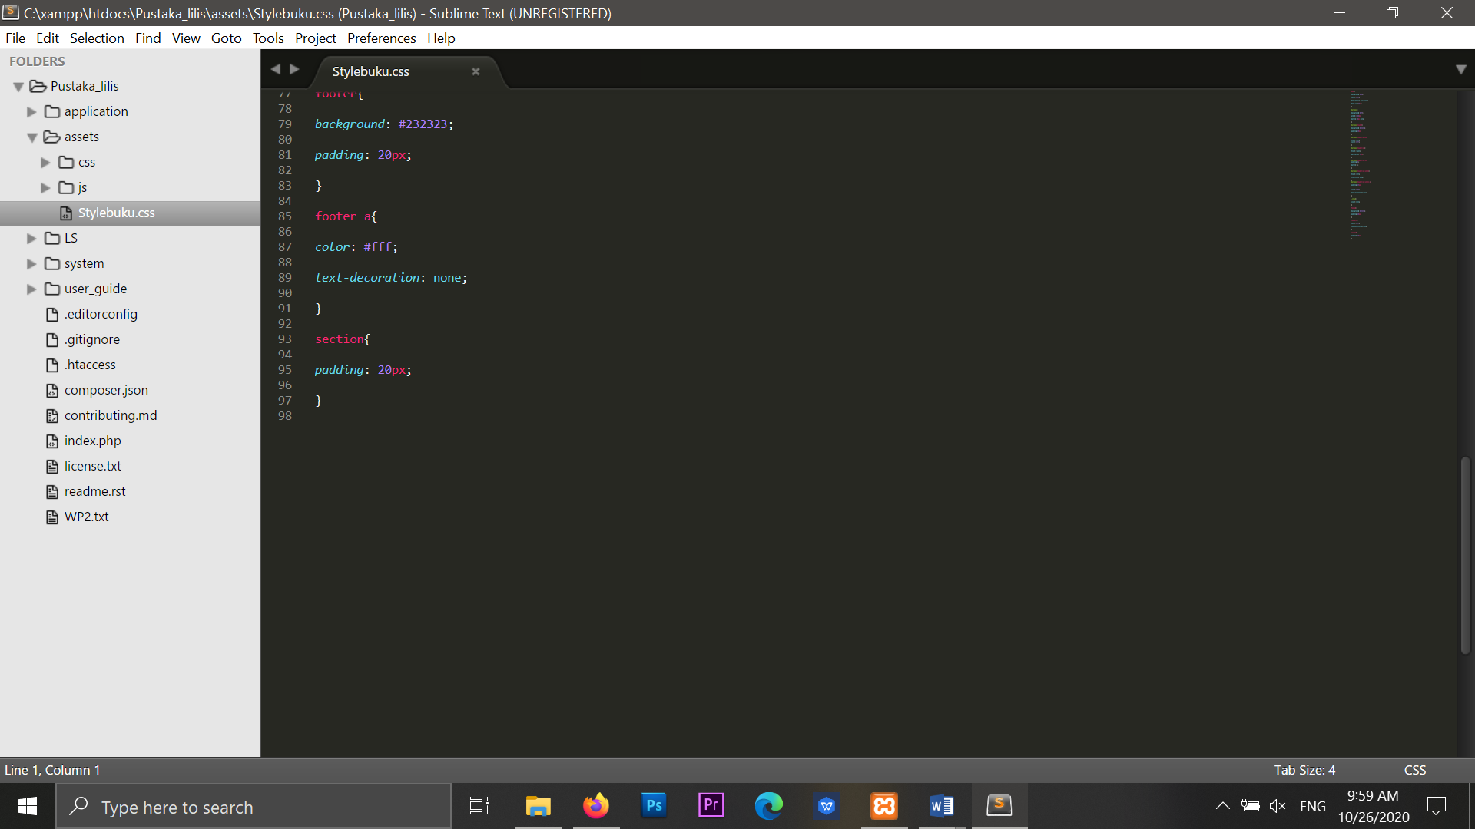

config.php => application / config

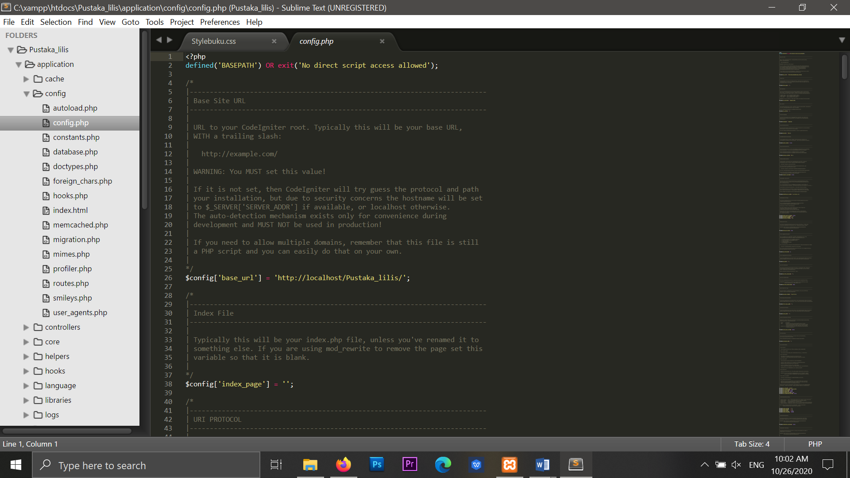

autoload.php => application / config

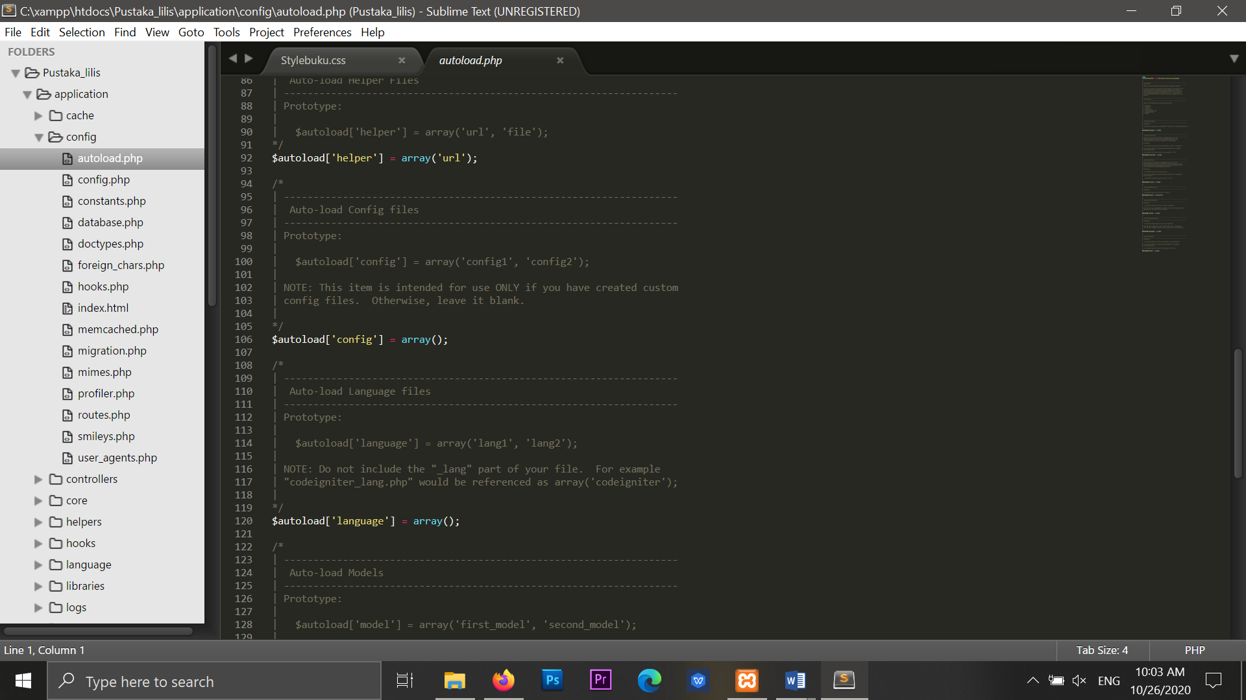

1. URL
2. [http://localhost/Pustaka_lilis /Web](http://localhost/Pustaka_lilis%20/Web)
3. [http://localhost/Pustaka_lilis /index.php/Web/about](http://localhost/Pustaka_lilis%20/index.php/Web/about)
4. Capture Hasil
5. Home

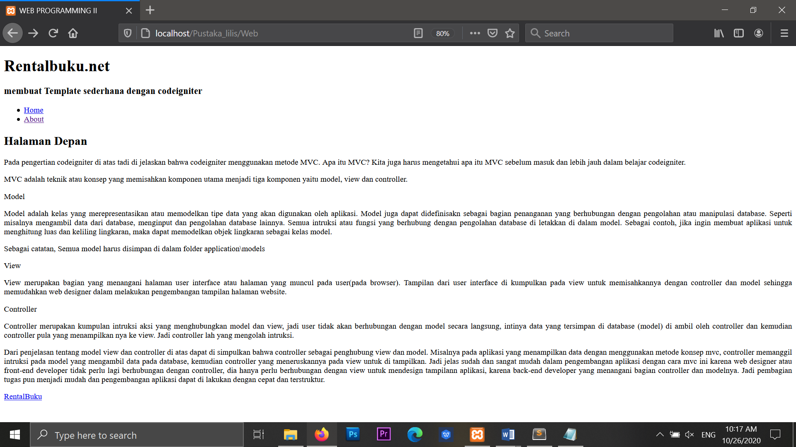

1. About

